20MCA136 – NETWORKING & SYSTEM ADMINISTRATION LAB Dept. of Computer Applications

|  |
| --- |
| **Name: VYSHNAV SURESSH**  **Roll No: 56**  **Batch: B**  **Date: 05-05-2022** |

**NETWORKING & SYSTEM ADMINISTRATION LAB**

**Experiment No.: 11**

**Aim**

Write a shell script to find largest of three numbers.

# Program

echo "Enter the value of a"

read a

echo "Enter the value of b"

read b

echo "Enter the value of c"

read c

if [ $a -gt $b ] && [ $a -gt $c] then

echo "the largest number is : "$a elif [ $b -gt $a ] && [ $b -gt $a ] then

echo "the largest number is :"$b else

echo "the largest number is :"$c

fi

# Output screenshot

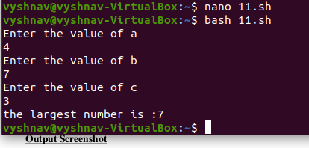

Amal Jyothi College of Engineering, Kanjirappally